**The Forest Inventory and Analysis: BigMAP User Documentation**

**July 24th, 2023**

**Contents**

**Preface**

**Abstract**

**Keywords**

**Authors**

**Background**

In 1928, Congress enacted the McSweeny-McNary Forest Research Act which states that, *“… a comprehensive survey of the present and prospective requirements for timber and other forest products of the United States…*” Thus began the Forest Inventory and Analysis (FIA) program, which collects Forest health Parameters such as condition, volume, growth, and use of trees on the Nations Forest land. FIA publishes yearly summary reports of the lands they survey, which benefits forest policies and programs across the United States.

These reports are constructed with the same information that is publicly available and can be found on the Forest Inventory and Analysis Database (FIADB). Most inventories can be located using this database, some information might not be available due to the changes in inventory sampling. As a widespread reach for national consistency, all annual inventories use a common plot design and common data collection procedures. These summary reports, written by Forest Service Personal can be found on the geospatial showcase hub.

The Big Data Mapping and Analytics platform (BIGMAP) is FIA’s could-based national scale modeling, mapping, and analysis environment for US Forests. The foundation of BIGMAP was established with the use of moderate spatial resolution imagery from MODIS to produce Continuous United States (CONUS) raster data sets on numerous forest attributes. The purpose of BIGMAP is to explore the capabilities of Esri Raster Analytics and ArcGIS Enterprise to support the integration of data collected on the ground and auxiliary information. This report should be used to navigate the geospatial showcase to locate BIGMAP layers and utilize them for further analysis.

Need to write about the intent of BIGMAP

GMAP intends to:

* Provide our users with simple ways to estimate forest attributes (and associated uncertainties), eliminating the need to understand how FIA stores and processes information.
* Provide maps and data services derived from the integration of FIA data and ancillary predictors are based upon peer-reviewed modeling approaches, and these models can be constructed to simultaneously protect plot security and provide reliable estimates of various forest attributes across a range of spatial scales
* Provide maps and data services of individual forest attributes can be combined easily with other content to provide integrative assessments(developed by the Agency as well as its partners)relevant to resource managers, policy-makers, and the interested publics that hold them accountable.

**Acknowledgements**

-Partnership with ESRI

**Chapter 1: Introduction**

1. Early stages of BigMAP
   * CONUS ([Characterization and visualization of the accuracy of FIA's CONUS-wide tree species datasets | US Forest Service Research and Development (usda.gov)](https://www.fs.usda.gov/research/treesearch/46519)
2. History of BigMAP development
   * Partnership between ESRI and FS

**Chapter 2: Raster format -Layer Catalog**

Raster images are comprised of pixels each one filled with information that when combined with other pixels create an image. The information that is collected from each pixel is information regarding the color and where it falls on the visible color spectrum, which can be manipulated to and interpretated to match real-time environmental conditions. This is the framework for remote sensing analytics and combined with data collected in the field many things can be harnessed.

BIGMAP uses Landsat imagery where each bucket represents a distribution of attribute values, stored in FIADB, that can be used as a machinery to make pixel-level predictions and maps of Forest resources. Statistical methods such as kNN algorithms and Harmonic Regressions are used to model forest attributes and order tree species along environmental gradients. Parallel processing outputs raster imagery which are stored on image services.

Image services exist for public use. To use an image service, first connect to the GIS server and navigate to your source data. Source data for BIGMAP can be found on the FIA Geospatial Showcase page under FIA BIGMAP General Layer Catalog.

**Chapter 3: Mosaic Dataset**

Mosaic datasets are used to manage collections of raster images stored in the geodatabase. The translation of raster imagery to mosaic dataset allows you to store, manage, view, and query your raster imagery quickly and efficiently. Their advanced raster querying capabilities and processing functions are a result of the referencing of the raster imagery rather than manipulating the source imagery.

A mosaic dataset is created and stored in the geodatabase through the geoprocessing toolbox. At first it is created empty where then the user can add an unlimited amount of raster imagery to the dataset. The images added to a mosaic dataset do not need to be continuous and can be pieced together so long as the coordinate system is the same.

It is best to store the image service layers from the BIGMAP catalog in mosaic datasets because of the ease at which the information can be cataloged and processed. The design at which mosaic datasets can handle varying resolutions all spectrally, spatially, temporarily, and radiometrically. As the mosaic datasets only reference the raster imagery while preforming functions the source pixels are never altered or converted, and the metadata remains intact.

Just like normal spatial layers mosaic datasets have attribute tables that are related to spatial data layers.

* **ObjectID**
* **Raster**
* **Name**
* **MinPS and MaxPS**
* **LowPS and HighPS**
* **Category**
* **Tag**
* **GroupName**
* **ProductName**
* **CenterX and Century**
* **ZOrder**

The three layers that are created through a mosaic dataset include: boundary, footprint, and image layer. The boundary layer displays the full extent of the raster imagery added to the mosaic dataset. The footprint layer reflects the extent for each individual raster image added to the mosaic dataset. Each footprint box corresponds to a unique row in the attribute table that can be used to query the data. The image layer is what controls the rendering of the data which can be manipulated through the stretch, RGB band combination, resampling, mosaic method, and other properties.

The seamline layer is another layer that can be added that acts similarly to the footprint layer in mosaicking images together.

Creating a mosaic dataset

1. In the geoprocessing window find: Create Mosaic Dataset
2. Graphical user interface, text, application, email

   Description automatically generatedAfter creating an empty mosaic dataset add raster’s of interest to the mosaic dataset

**Chapter 4: Creating an Area of Interest**

Creating an Area of Interest- Northern Hardwood Forest

Creating an Area of Interest is a process that entails clipping the raster imagery down to the specified extent.

For this demonstration, I will be adding in raster imagery that can be found in the Northern Hardwood Forests of Vermont. I will then clip these images down to the extent of the Green Mountain National Forest.

1. Upload .shp file that contains your area of interest
2. Create an empty mosaic dataset
3. Add the selected image service to the empty mosaic data set
4. 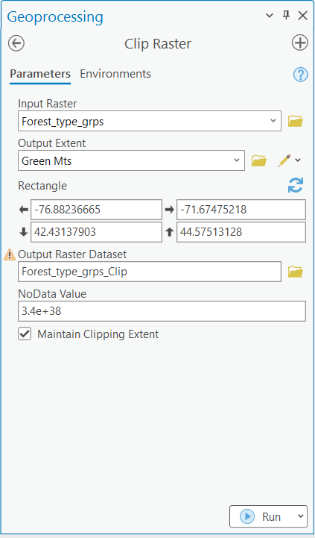Clip raster

Focus on finding areas that have certain forest types

AOI: Green Mountain National Forests

The forest types that make up VT: Northern Hardwood (dominant), White/red pine, spruce fir, Aspen birch

-Sugar maple

-Balsam fir

-American Beech

-Red maple

-Red spruce

-Yellow Birch

-Eastern Hemlock

-Paper Birch

-White ash

-Eastern White Pine

Pixel count vs. Evalidator basal area

Steps: Load all of the trees that make of Vermont aand through an analysis find the areas that are an Aspen Birch Forest. This will be the area where there is overlap between the aspen and birch species.

1. [The forests of the Green Mountain State (usda.gov)](https://www.fs.usda.gov/ne/newtown_square/publications/resource_bulletins/pdfs/2003/ne_rb158.pdf)
2. Clipping to a polygon -> import mosaic dataset geometry
3. Joining to a .shp

**Chapter 5: Geoprocessing tools/ Raster functions**

1. Calculate Cell pixel statistics
2. Band Arithmetic function- self created functions
3. Zonal statistics as a table

**Chapter 6: Use Cases – Choose 2 or 3**

* Characterizing Site index zones- Urban development related to WUI and management practices of local forests
* Averaging Forest Biomass

**Chapter 7: Validation data**

1. Hex validation
   1. Levels
2. Accuracy Assessment
   1. Reduced major axis regression

**Chapter 8: Common errors/troubleshooting**

1. [Mosaic Dataset Analyzer: Error 70100—ArcMap | Documentation (arcgis.com)](https://desktop.arcgis.com/en/arcmap/latest/manage-data/raster-and-images/mosaic-dataset-analyzer-error-70100.htm)

**Chapter 9: Creating a connection through Python**

**Chapter 10: Tool development**

1. Dashboard Mike made.
2. Proposed tools and future development

**Literature Cited**

**Appendix**